# Placa PPI NB-IoT

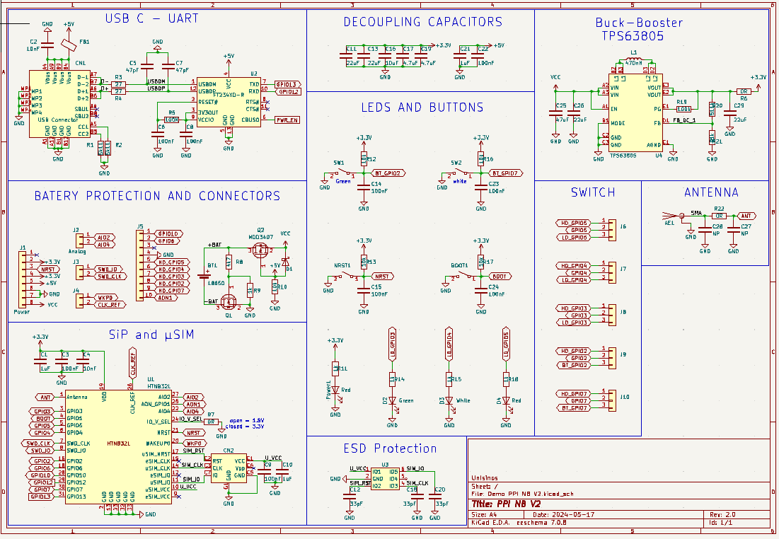

Figura - Schematic PPI NB

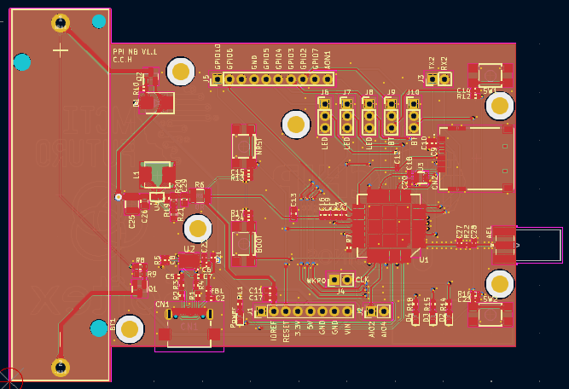

Figura - Layout 2D PPI NB

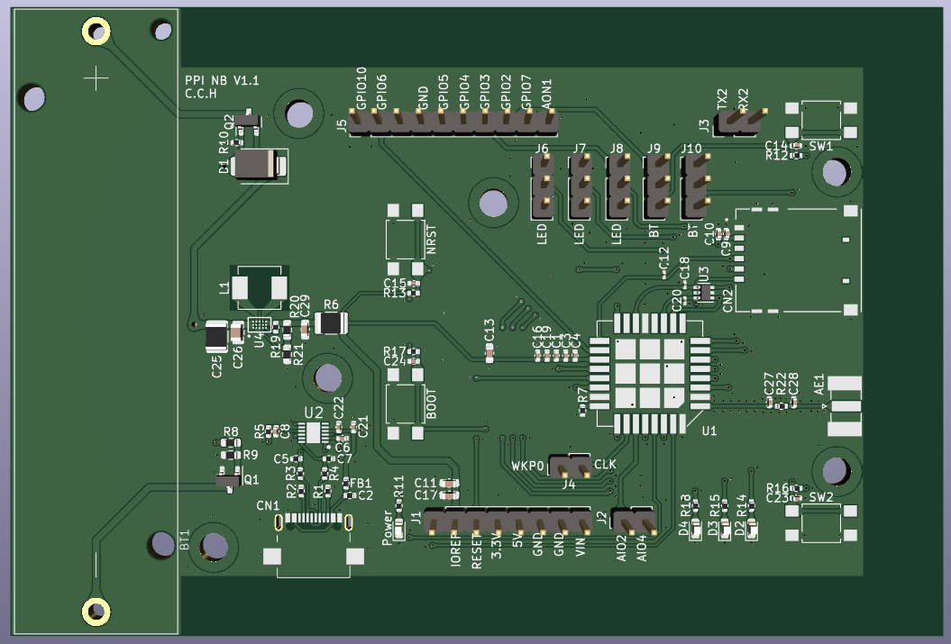

Figura - Layout 3D PPI NB

* Short the Middle pin and the lower pin of J6, J7, J8, J9, J10 you can use the Led D4, D3, D2 and SW1 and SW2 button respectively.
* Short the Middle pin and the Upper pin of J6, J7, J8, J9, J10 you can use the GPIO5, GPIO4, GPIO3, GPIO2 and GPIO7 pins respectively.